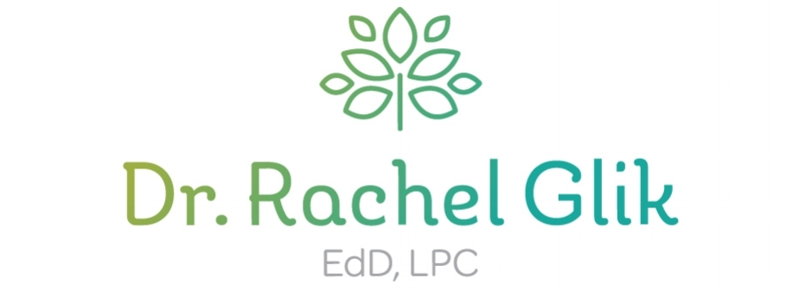
A COUNSELOR FOR SOUL SEARCHERS

225 S. Meramec Ave, Suite 310, Clayton, MO 63105
www.drrachelglik.com 314.341.4205

Couples Counseling Information and Preparation Questions

Name ________________________________________ Cell __________________________
Email ________________________________________ Today’s Date ___________________
Date of Birth ______________Spouse’s Name & Date of Birth___________________________

What is the best outcome you hope will come from couples counseling?

What did you expect marriage or a committed relationship would be like?

On a 1 to 10, how committed do you feel right now to working on making this relationship work?

What personal traits, thoughts or behaviors of yours do you think hinder the closeness between you and your partner?

What role does spirituality or religion play in your personal life and/or in your relationship?

What aspect of creating a fulfilling, long-lasting relationship do you feel most confused about?

What do you appreciate about your partner?

To what extent do you feel fulfilled within your own life and your own self?

